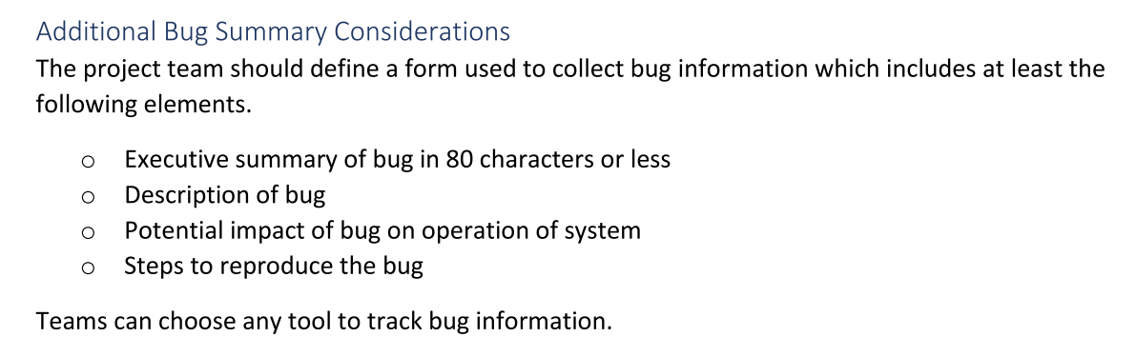

The project team should define a form used to collect bug information which includes at least the following elements.

* Executive summary of bug in 80 characters or less
* Description of bug o Potential impact of bug on operation of system o Steps to reproduce the bug

Teams can choose any tool to track bug information

Sometimes I delete the to-do, and it deletes the corresponding category/projects as well

BUGS: Xml does not work (1) when you submit an id with it just as it is documented (2) you can’t submit a body in xml to create a relationship between todo and category/project as it won’t find the corresponding object with that ID.